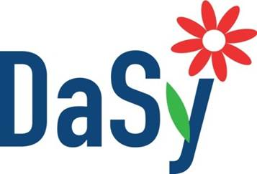

Stakeholder Engagement
Stakeholder Analysis – Identifying Engagement Strategies
Instructions for Part 1: Using the table below, consider and prioritize the different kinds of challenges you may have when engaging with your data systems stakeholders. This will be helpful in determining the engagement strategies you select in Part 2.
Please refer to the Stakeholder Engagement Techniques handout to support your decisions about the types of engagement strategies you’ll use.

Considerations for Selecting Engagement Strategy | Amount of time you have to engage with stakeholders is significantly limited. | Budget to cover the costs of gathering input from stakeholders is limited. | Geographic locations of stakeholders are dispersed. | Range of stakeholder perspectives, experiences and/or characteristics varies widely. | Lack of existing relationships with and/or among stakeholders | Stakeholders have very limited availability | There are many potential stakeholders | Stakeholders have little familiarity with data systems work | The data systems work is complex
Is this a critical factor?
(Rank Top three considerations)

Instructions for Part 2: Using the table below, identify the engagement strategies you will use for each stakeholder. Consider when the input from that stakeholder or group of stakeholders is needed (timing) and the resources you’ll need in order to engage the individual and/or group. Consider both formal and informal ways in which stakeholder input may be gathered.
Please reference the Stakeholder Engagement Techniques handout to support your decisions.
Data System Project or Initiative:

Engagement Technique | I will use this technique  (Check all that apply) | To engage these stakeholders  (List individuals and/or groups) | Timing  (List sequence and/or dates) | Resources Needed  (List funding, staff, other resources required)
One – on – One or Individual
One-on-one interviews
Email
Other
Group Meetings
Brainstorming
Presentation/ Discussion
Inquiry
Focus group
Moderated discussions (online/ video/ phone)
Other

Surveys
One-time survey
Delphi Technique
Other

Suggestions
- Remember that all stakeholders don’t have to be involved in every interaction. Carefully consider each person’s role and influence (from the stakeholder profile information) and select engagement strategies to support that particular stakeholder’s engagement.

Resource- Adapted from:
Preskill, H. & Jones, N. (2009). A Practical Guide for Engaging Stakeholders in Developing Evaluation Questions. Robert Wood Johnson Foundation, Princeton, NJ. Retrieved from http://www.rwjf.org/pr/product.jsp?id=49951

